


School of Computer Science and Engineering
Lovely Professional University, Phagwara, Punjab (India)
Month: December
Year: 2025

ROAD ACCIDENT ANALYSIS IN INDIA
Exploratory Data Analysis, Statistical Investigation and Interactive Visualization Using Tableau
Final Report

Submitted By: Ayushman Behera
Reg no: 12301257
SUPERVISOR’S CERTIFICATE

This is to certify that the work reported in the B. Tech Dissertation/dissertation proposal entitled “Road Accident Analysis in India”, submitted by Ayushman Behera at Lovely Professional University, Phagwara, India is a Bonafide record of his original work carried out under my supervision. This work has not been submitted elsewhere to any other degree.

Signature of Supervisor
Hritwiz Yash
Date: 16 December 2025
Acknowledgement

I hereby declare that the research work reported in the dissertation/dissertation proposal entitled “Road Accident Analysis in India” in partial fulfilment of the requirement for the award of Degree for Bachelor of Technology in Computer Science and Engineering with specialization in Data Science with Machine Learning at Lovely Professional University, Phagwara, Punjab is an authentic work carried out under supervision of my research supervisor Mr. Hritwiz Yash. I have not submitted this work elsewhere for any degree or diploma.
I understand that the work presented herewith is in direct compliance with Lovely Professional University’s Policy on plagiarism, intellectual property rights, and high standards of moral and ethical conduct. Therefore, to the best of my knowledge, the content of this dissertation represents authentic and honest research effort conducted, in its entirety, by me. I am fully responsible for the contents of my dissertation work.

Signature of Candidate
Name of Candidate: Ayushman Behera
Registration Number: 12301257

S. No. | Content | Page Number
1 | Introduction | 6
2 | Problem Statement | 6
3 | Objectives of the Study | 7
4 | Dataset Description | 7
5 | Data Understanding and Initial Exploration | 8
6 | Data Quality Assessment | 8
7 | Outlier Detection and Treatment | 9
8 | Data Standardization | 12
9 | Univariate Analysis | 13
S. No. | Content | Page Number
10 | Bivariate Analysis | 17
11 | Multivariate Analysis | 18
12 | Statistical Inference | 18
13 | Tableau Dashboard Analysis | 20
14 | Key Findings | 23
15 | Limitations of the Study | 24
16 | Conclusion | 24
17 | Tools and Technologies Used | 24
18 | References | 25

1. Introduction
Road traffic accidents represent one of the most critical public safety challenges in India, accounting for a significant proportion of fatalities, injuries, and economic losses each year. With rapid urbanization, exponential growth in vehicle ownership, uneven road infrastructure, and diverse driving behaviours, India’s road transport system has become increasingly complex. According to national transport and health statistics, road accidents not only result in loss of human life but also impose long-term socio-economic consequences on families and communities. These include healthcare expenditures, productivity loss, legal costs, and psychological trauma.
In recent years, the availability of digital accident records has increased substantially due to improved reporting mechanisms and data collection by government agencies. However, raw datasets alone are insufficient for understanding accident dynamics. Without systematic analysis, crucial insights related to accident severity, environmental impact, road characteristics, and temporal trends remain hidden. This necessitates the application of Exploratory Data Analysis (EDA), which serves as the foundational step in any data-driven investigation.
Exploratory Data Analysis focuses on summarizing the main characteristics of data using statistical measures and visual techniques. Unlike predictive modelling, EDA emphasizes understanding data behaviour, identifying anomalies, examining relationships among variables, and forming evidence-based hypotheses. In safety-critical domains such as road accident analysis, EDA is particularly valuable because it highlights risk patterns and severity indicators before any intervention strategies are designed.
This project performs an in-depth exploratory analysis of Indian road accident data using Python-based statistical methods and visualization techniques. Furthermore, the project integrates Tableau dashboards to convert static analytical findings into interactive visual insights. Instead of applying machine learning models, the emphasis is placed on interpretability, visual storytelling, and decision support, making the results accessible to non-technical stakeholders such as policymakers and traffic authorities.
--------------------------------------------------------------------------------------------------------------
2. Problem Statement
Despite the large volume of road accident data collected annually in India, actionable insights derived from this data remain limited. Existing analyses often rely on high-level aggregated statistics such as total accidents or fatalities per year, which fail to capture the complex interactions between multiple contributing factors. Variables such as road type, speed behaviour, lighting conditions, weather, and vehicle involvement interact in non-linear ways that are not evident from summary tables alone.
Additionally, many analytical studies focus heavily on predictive modelling using machine learning techniques, often at the expense of thorough exploratory understanding. While prediction has its value, it does not necessarily explain why accidents occur or which factors contribute most significantly to severity. For policy formulation and road safety planning, interpretability and transparency are often more important than prediction accuracy.
Therefore, the central problem addressed in this project is the lack of a structured exploratory and visual analysis framework that systematically examines Indian road accident data to identify severity patterns, risk factors, and trends without relying on black-box predictive models.
--------------------------------------------------------------------------------------------------------------
3. Objectives of the Study
The primary objective of this project is to perform a comprehensive exploratory data analysis of Indian road accident data to uncover meaningful patterns related to accident frequency, severity, and contributing conditions. The study aims to clean and preprocess raw accident data, identify anomalies and outliers, and apply statistical techniques to summarize and interpret data behaviour.
Secondary objectives include performing univariate, bivariate, and multivariate analyses to examine relationships among variables, applying statistical inference techniques to validate observations, and designing an interactive Tableau dashboard that visually communicates key findings. The project ultimately seeks to demonstrate that EDA combined with interactive visualization can support effective road safety decision-making without machine learning integration.
--------------------------------------------------------------------------------------------------------------
4. Dataset Description
The dataset used in this project consists of 22,500 individual road accident records with 18 attributes, representing accident occurrences across various Indian states and cities. Each record corresponds to a unique accident event and includes temporal, geographical, environmental, and severity-related information.
The dataset contains a mixture of categorical and numerical variables, enabling diverse analytical techniques. Categorical variables describe qualitative aspects such as state, city, road type, weather conditions, and lighting conditions. Numerical variables capture quantitative measures such as speed limits, estimated vehicle speed, number of vehicles involved, casualties, fatalities, injury counts, and economic damage.
The presence of both discrete and continuous variables allows for extensive exploratory analysis, including distribution analysis, correlation studies, and categorical comparisons. The dataset size is sufficiently large to support statistical inference and reduce sampling bias.

Code Snippet:
df = pd.read_csv("indian_road_accidents.csv")
df.shape
df.info()
df.describe()

--------------------------------------------------------------------------------------------------------------
5. Data Understanding and Initial Exploration
Initial data exploration was conducted to understand the structural composition of the dataset. The info() function revealed data types, non-null counts, and memory usage, while describe() provided statistical summaries such as mean, median, standard deviation, and range for numerical attributes.
This step helped identify potential data quality issues such as missing values and outliers. It also provided early indications of skewness in variables related to casualties and damage cost, suggesting the presence of rare but severe accident events.
--------------------------------------------------------------------------------------------------------------
6. Data Quality Assessment
6.1 Duplicate Record Analysis
Duplicate records were examined to ensure that each accident event was represented uniquely. Duplicate entries can artificially inflate accident counts and bias frequency-based visualizations.

Code Snippet:
df.duplicated().sum()

No duplicate records were found, confirming data integrity.
--------------------------------------------------------------------------------------------------------------
6.2 Missing Value Analysis
Missing values were identified in several columns, particularly weather conditions, lighting conditions, estimated speed, alcohol involvement, and damage cost. Missing data is common in large administrative datasets due to reporting inconsistencies and field-level constraints.
Removing rows with missing values would result in loss of valuable information and reduce dataset representativeness. Therefore, imputation techniques were applied.

Code Snippet:
for col in num_cols:
df[col] = df[col].fillna(df[col].mean())
for col in cat_cols:
df[col] = df[col].fillna(df[col].mode()[0])

Mean imputation preserves numerical distribution, while mode imputation maintains categorical dominance. After imputation, the dataset contained no missing values.
--------------------------------------------------------------------------------------------------------------
7. Outlier Detection and Treatment
Outliers were detected using boxplots and interquartile range (IQR) analysis. Variables such as estimated speed, casualties, and damage cost exhibited extreme values.
Outliers in accident data often represent high-impact real-world events rather than measurement errors. Removing such observations would eliminate critical safety information. Therefore, IQR-based capping was applied to limit extreme influence while retaining all records.

Code Snippet:
Q1 = df[col].quantile(0.25)
Q3 = df[col].quantile(0.75)
IQR = Q3 - Q1
df[col] = np.clip(df[col], Q1 - 1.5*IQR, Q3 + 1.5*IQR)

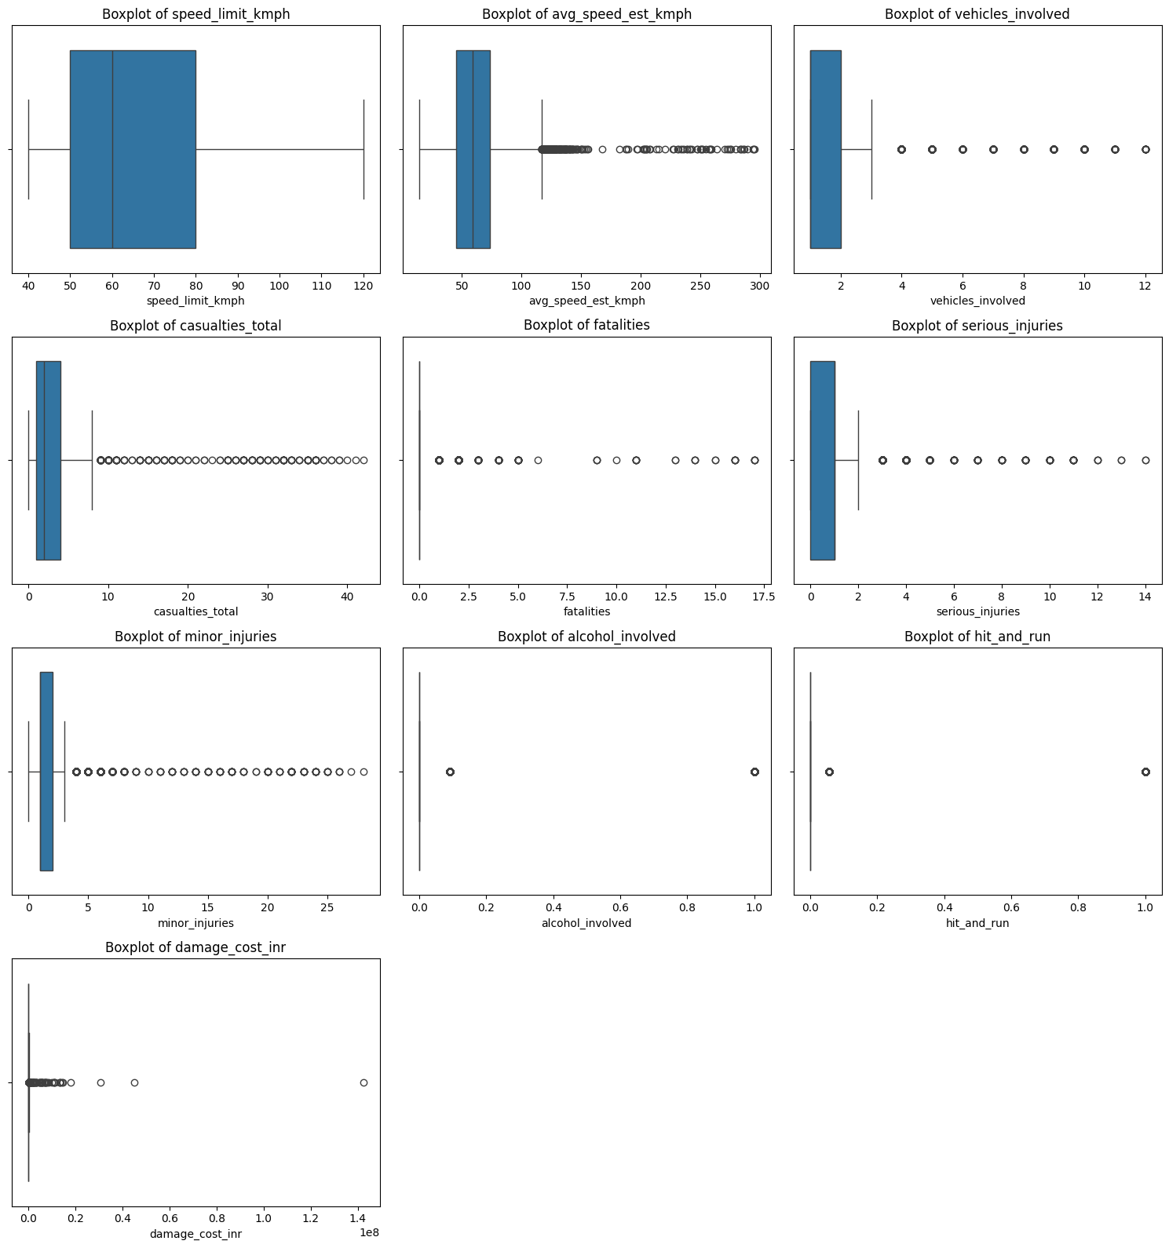

Figure 1: Boxplot Before Outlier Detection

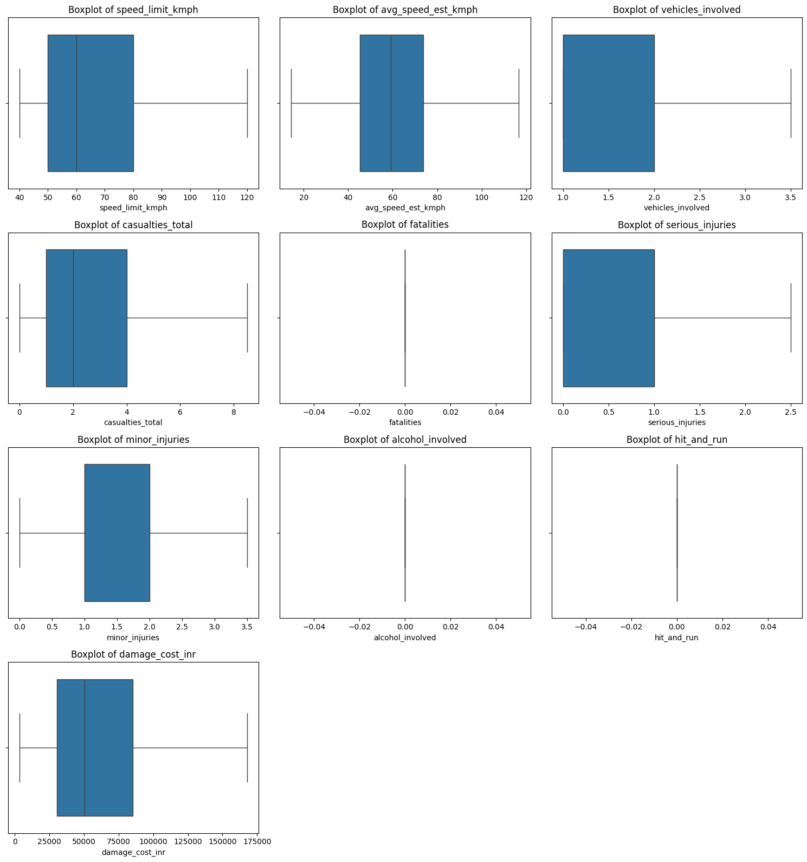

Figure 2: Boxplot After Outlier Detection

8. Data Standardization
Standardization was applied to numerical variables using Z-score normalization to ensure comparability across different measurement scales.

Code Snippet:
scaler = StandardScaler()
df[num_cols] = scaler.fit_transform(df[num_cols])

This step improves interpretability, especially in correlation analysis and multivariate visualization.

9. Univariate Analysis
Univariate analysis focuses on examining each variable independently to understand its distribution, spread, central tendency, and variability. In the context of road accident analysis, univariate exploration is crucial for identifying dominant accident characteristics, skewness in severity-related variables, and the presence of rare but extreme events. This section uses histograms, kernel density estimation (KDE) plots, and violin plots to study numerical variables related to speed, casualties, injuries, and economic damage.

9.1 Histogram Analysis
Histograms were used to visualize the frequency distribution of numerical variables. They provide insight into data shape, skewness, concentration, and dispersion.

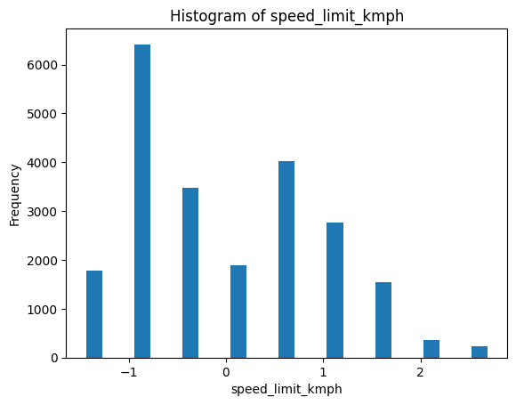
Histogram of Speed Limit (km/h)
The histogram of speed limits shows a multi-peaked distribution, indicating the presence of multiple road categories such as urban roads, state highways, and national highways. Lower
speed limits dominate the distribution, reflecting the prevalence of urban and semi-urban road networks in India. This suggests that although high-speed roads exist, most accidents occur on roads with moderate speed limits.
From an accident severity perspective, this implies that severity is not solely dependent on speed limits but also on factors such as traffic density and road design.

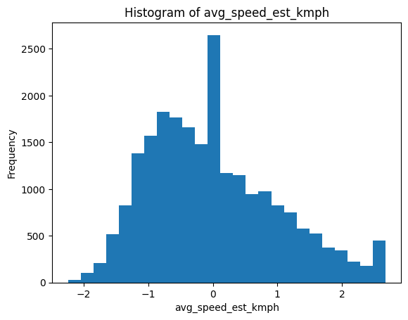
Histogram of Estimated Average Speed
The estimated average speed distribution is moderately right skewed, with a long tail toward higher speeds. Most accidents occur within a moderate speed range, while a smaller proportion involves very high speeds. These extreme values often correspond to highway or expressway accidents and are associated with increased severity.
The skewness indicates that while high-speed accidents are less frequent, they are potentially more dangerous, contributing disproportionately to fatalities and serious injuries.

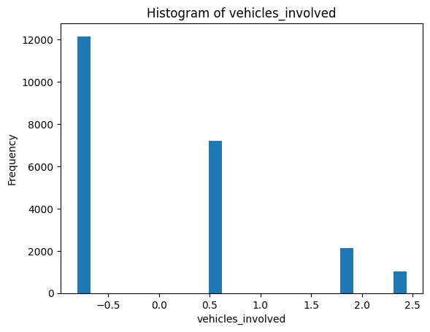
Histogram of Vehicles Involved
This histogram exhibits strong right skewness, with most accidents involving one or two vehicles. However, the presence of a long tail indicates multi-vehicle collisions, which are relatively rare but often severe.
Multi-vehicle accidents increase the likelihood of chain collisions, higher casualty counts, and greater economic damage, highlighting their importance in safety planning.

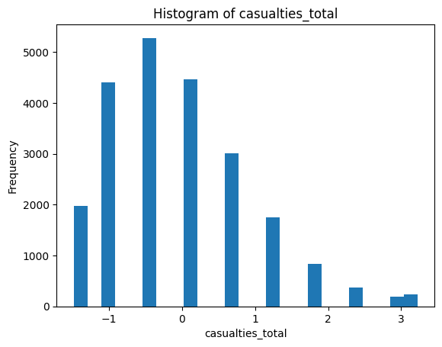
Histogram of Total Casualties
The casualty’s distribution is highly right-skewed. A large proportion of accidents result in few or no casualties, while a small number of accidents involve very high casualty counts. This imbalance confirms that road accidents follow a “low-frequency, high-impact” pattern.
From a policy standpoint, this indicates that targeted interventions addressing high-risk scenarios could significantly reduce overall harm.
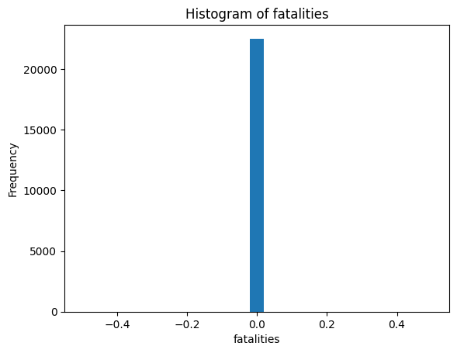
Histogram of Fatalities
The fatalities histogram shows a heavy concentration at zero, indicating that most accidents are non-fatal. However, a small number of cases involve multiple fatalities, emphasizing the catastrophic nature of certain accidents.
This distribution highlights the need for preventive strategies focused on reducing fatal accident probability rather than merely reducing accident counts.
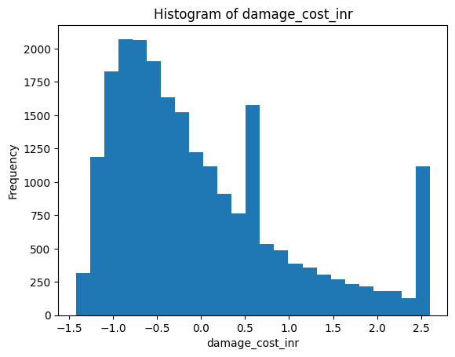
Histogram of Damage Cost (INR)
The damage cost histogram shows extreme positive skewness with a long right tail. While most accidents result in relatively low economic loss, a few incidents incur extremely high costs due to infrastructure damage, vehicle loss, or severe injuries.
This reinforces the economic burden posed by rare but severe accidents.

9.2 Kernel Density Estimation (KDE) Analysis
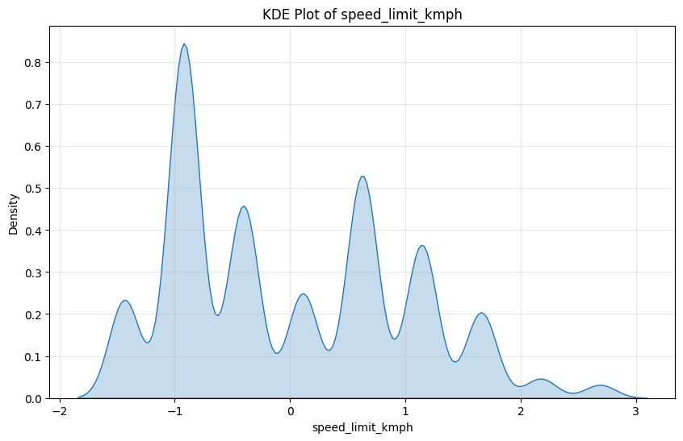
KDE plots provide a smooth approximation of the underlying probability density function, overcoming the bin dependency of histograms.
KDE of Speed
The KDE curve for speed reveals multiple density peaks, indicating heterogeneous driving conditions. These peaks correspond to different road environments such as urban streets and highways. This heterogeneity suggests that accident risk varies significantly across driving contexts.
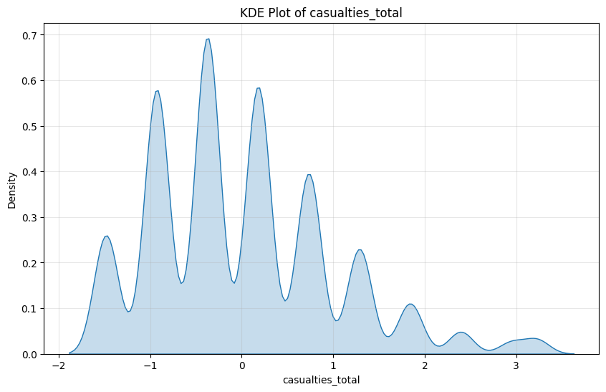
KDE of Casualties
The KDE for casualties shows high density near lower values with gradual tapering toward higher counts. This confirms that most accidents are low severity, but the probability of severe outcomes, though low, is non-negligible.

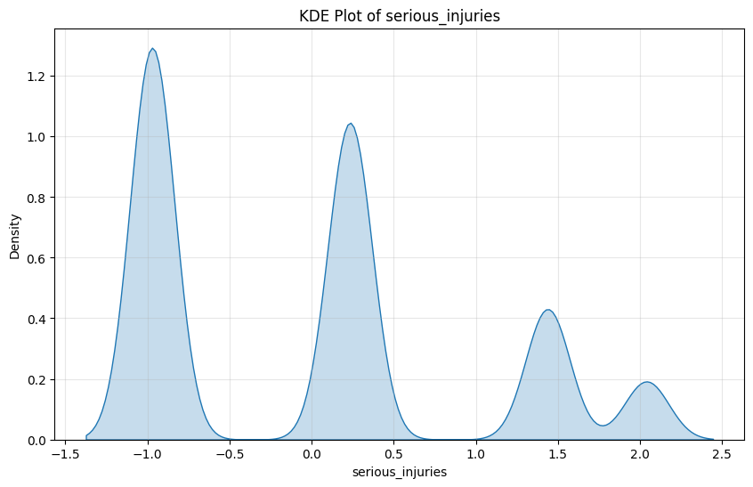
KDE of Serious Injuries
The density curve indicates clustering around low injury counts with secondary peaks, reflecting varying accident intensities. This supports the presence of multiple accident severity regimes.
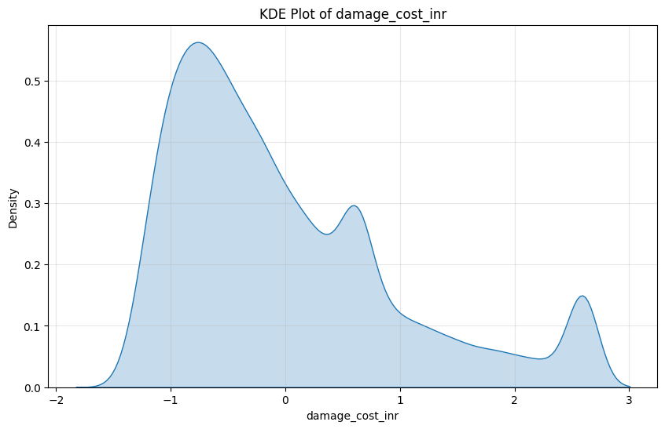

KDE of Damage Cost
The KDE plot confirms strong positive skewness and heavy tails, reinforcing the presence of rare, high-cost accident events.

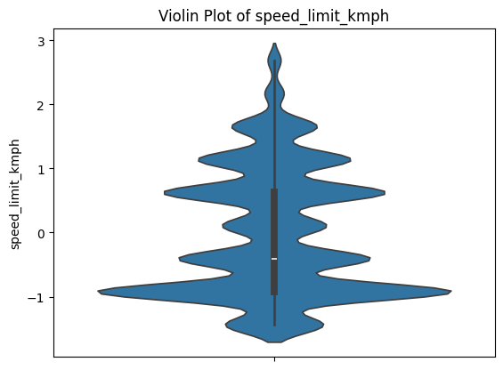
9.3 Violin Plot Analysis
Violin plots combine boxplot statistics with density estimation, offering a comprehensive view of distribution shape and concentration.
Violin Plot of Speed
The plot shows dense concentration around moderate speeds with extended tails. This indicates that while extreme speeds are less frequent, they remain present and influential.
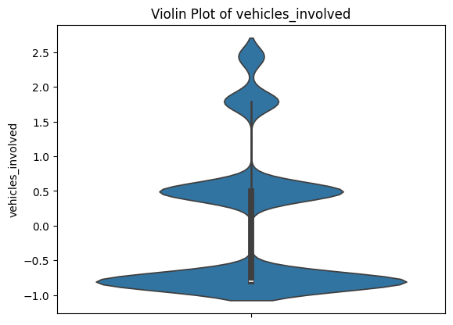
Violin Plot of Casualties
The violin plot highlights a narrow concentration near low casualty values and a long upper tail, reinforcing the imbalance between frequent minor accidents and rare severe ones.
Violin Plot of Damage Cost
The plot reveals high density at low costs and sparse density at extreme values, emphasizing economic vulnerability caused by a small fraction of accidents.
10. Bivariate Analysis
Bivariate analysis examines relationships between two variables to identify associations, trends, and dependencies.

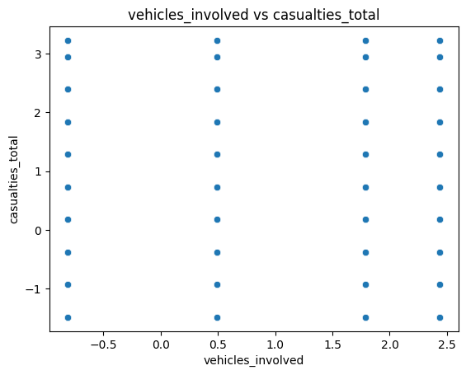
10.1 Scatter Plot Analysis
Speed vs Casualties
The scatter plot shows a weak positive relationship between speed and casualties. While higher speeds are associated with higher casualty counts, the relationship is not strictly linear. Significant clustering at moderate speeds suggests that other factors, such as traffic density and road design, influence severity.
This highlights the limitation of relying solely on speed control as a safety measure.
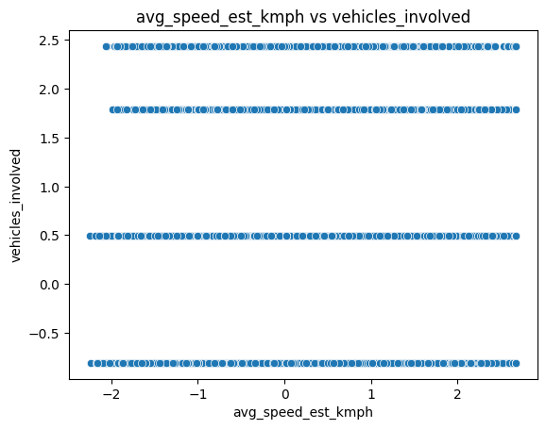

Vehicles Involved vs Injuries
A clearer positive relationship is observed between the number of vehicles involved and injury counts. Multi-vehicle collisions tend to result in higher injury severity, emphasizing the importance of traffic management and congestion control.

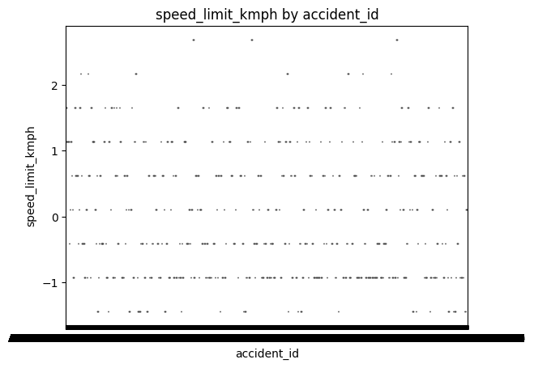
10.2 Boxplot Analysis by Road Type
Speed by Road Type
National highways and expressways exhibit higher median speeds and greater variability, while urban roads show lower speeds with tighter distributions. This reflects infrastructural and regulatory differences.
Casualties by Road Type
Casualties are higher and more variable on highways, indicating that accidents on high-speed roads are more severe despite lower frequency.

11. Multivariate Analysis
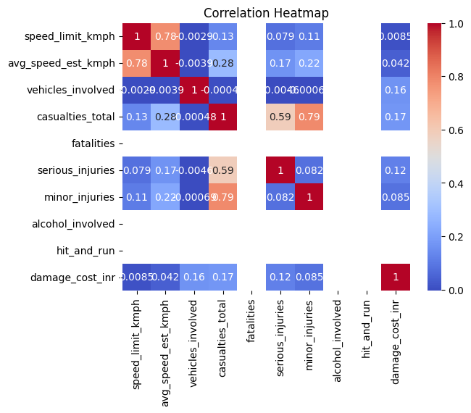
Correlation Heatmap
The correlation heatmap provides a comprehensive overview of linear relationships among numerical variables. Strong positive correlations are observed between casualties, serious injuries, and minor injuries, indicating that these variables jointly describe accident severity.
Speed limit shows moderate correlation with estimated speed, while damage cost correlates positively with injury severity. Importantly, correlation does not imply causation. These relationships highlight associations but must be interpreted within real-world context.
From a policy perspective, variables with strong correlations can be targeted simultaneously to reduce severity.

12. Statistical Inference
Statistical inference techniques were applied to validate patterns observed during exploratory analysis.
Probability Concepts
Basic probability rules were used to explain event likelihood and independence, forming the foundation for further inference.
Normal Distribution
The normal distribution was plotted to demonstrate continuous probability behaviour and to serve as a reference distribution for inferential methods.
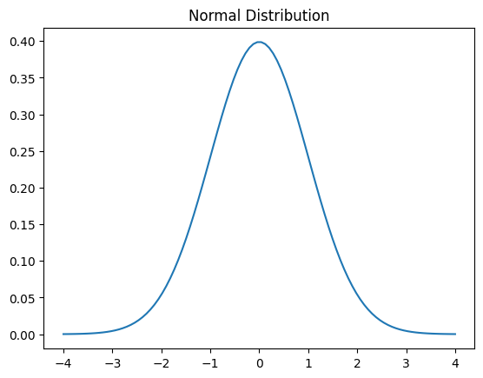

Central Limit Theorem
Repeated sampling and plotting of sample means resulted in an approximately normal distribution, validating the Central Limit Theorem. This justifies the use of parametric tests even when original data is skewed.

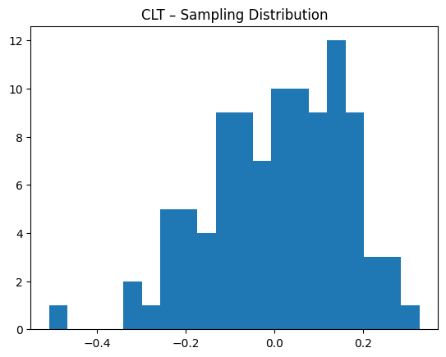
Confidence Interval Estimation
A confidence interval was computed to estimate population parameters with uncertainty awareness, emphasizing reliability over point estimates.

Hypothesis Testing
One-sample and two-sample t-tests, along with chi-square tests, were conducted to examine statistical significance. Results indicated that many observed differences were not due to random chance, reinforcing analytical findings

13. Tableau Dashboard Analysis

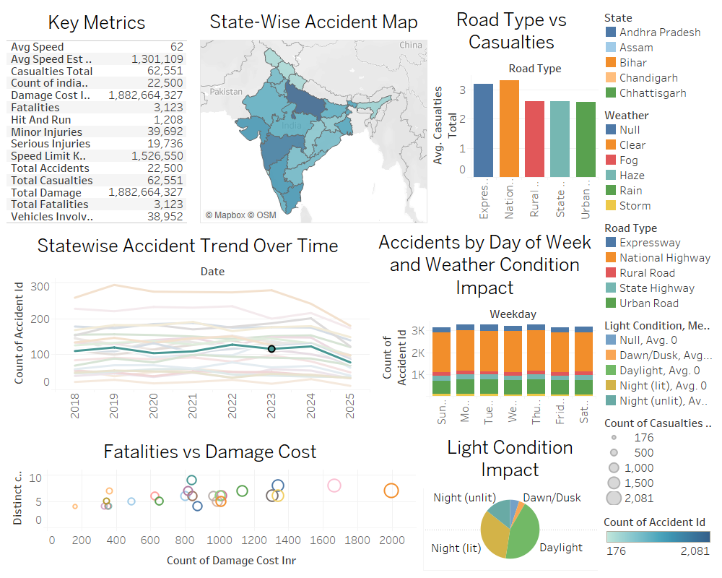

13.1 Rationale for Using Tableau for Visual Analytics
While Python-based visualizations are extremely powerful for exploratory and statistical analysis, they are largely static in nature. Static graphs, although useful for identifying patterns during analysis, limit the ability of non-technical stakeholders to interact with the data. Decision-makers such as transport authorities, policymakers, and urban planners often require tools that allow them to explore data dynamically, apply filters, and examine specific regions or conditions without writing code.
Tableau was therefore selected as a complementary visualization tool for this project. Tableau enables interactive, multi-dimensional data exploration, allowing users to drill down into accident data based on state, road type, weather condition, lighting condition, and time. Unlike static plots, Tableau dashboards update in real time as filters are applied, making insights more intuitive and actionable.
Another major advantage of Tableau is its ability to combine multiple visual components—maps, bar charts, trend lines, and KPIs—into a single coherent dashboard. This integrated view helps stakeholders understand the broader accident scenario at a glance while still allowing deeper investigation into specific aspects. Since the objective of this project is exploratory understanding and decision support rather than prediction, Tableau aligns perfectly with the project goals.

13.2 Dashboard Component Analysis
The Tableau dashboard designed for this project integrates multiple visual elements, each targeting a specific dimension of road accident analysis. Together, these components provide a holistic overview of accident severity, spatial distribution, and contributing factors.

13.2.1 Key Performance Indicator (KPI) Panel
The Key Performance Indicator (KPI) panel is positioned prominently at the top of the dashboard to provide an immediate quantitative summary of the dataset. This panel displays metrics such as total number of accidents, total casualties, total fatalities, average estimated speed, and total economic damage cost.
The purpose of this panel is to offer instant situational awareness. Instead of navigating through raw data or multiple charts, stakeholders can immediately assess the overall magnitude of road accidents and their impact. For example, high casualty and fatality figures alongside significant economic damage emphasize the seriousness of the problem at a national level.
From an analytical perspective, the KPI panel serves as a reference point against which other visualizations can be interpreted. When filters are applied—such as selecting a specific state or road type—the KPIs update dynamically, allowing users to compare regional or contextual variations in accident severity.

13.2.2 State-wise Accident Map
The state-wise accident map provides a geographic visualization of accident distribution across India. Each state is shaded based on accident count or severity metrics, enabling quick identification of high-risk regions.
This spatial representation reveals clear geographic disparities in road accidents. States with dense urbanization, higher vehicle population, or extensive highway networks tend to show higher accident concentrations. The map allows policymakers to visually prioritize regions that require urgent intervention, such as improved infrastructure, stricter enforcement, or targeted awareness campaigns.
Additionally, the interactive nature of the map allows users to click on a specific state and instantly update other dashboard components. This linkage between spatial and numerical views enhances exploratory analysis and supports region-specific decision-making.

13.2.3 Road Type vs Casualties
The road type versus casualties’ visualization compares accident severity across different road categories such as urban roads, rural roads, state highways, national highways, and expressways.
This chart clearly indicates that highways and expressways tend to have higher average casualties per accident compared to urban roads. Although urban roads experience a higher frequency of accidents, highway accidents are generally more severe due to higher speeds and limited reaction time.
This finding reinforces insights obtained during Python-based bivariate analysis and highlights the importance of road-specific safety strategies. For instance, urban road safety measures may focus on congestion management, while highway safety may prioritize speed enforcement, median barriers, and emergency response systems.

13.2.4 Weather and Light Condition Impact
This component analyses accident patterns under different weather and lighting conditions. The visualization shows that accidents occurring during poor lighting conditions (such as unlit nights or dawn/dusk) and adverse weather (fog, rain, storms) tend to exhibit higher severity.
Reduced visibility, slippery road surfaces, and delayed reaction times significantly increase accident risk under such conditions. This visualization emphasizes the critical role of infrastructure improvements such as proper street lighting, reflective road markings, and weather-responsive traffic advisories.
The ability to filter accidents by weather or light condition allows stakeholders to assess how environmental factors interact with other variables like road type and speed, providing deeper insight into accident causation.

13.2.5 Fatalities vs Damage Cost
The fatalities versus damage cost bubble chart illustrates the relationship between human loss and economic impact. Each bubble represents a set of accident conditions, with size or colour encoding severity.
The visualization shows that accidents involving fatalities often correspond to disproportionately higher economic damage. This compounded impact highlights that fatal accidents not only result in loss of life but also impose significant financial burdens due to vehicle destruction, medical costs, legal proceedings, and infrastructure repair.
From a policy standpoint, this visualization supports investment in preventive measures, as reducing fatal accidents can simultaneously reduce economic losses.

13.3 Overall Significance of the Tableau Dashboard
The Tableau dashboard transforms complex accident data into an intuitive, interactive decision-support tool. By integrating multiple analytical dimensions into a single platform, it enables holistic understanding and encourages data-driven policymaking. The dashboard complements Python-based EDA by extending insights beyond static analysis and making them accessible to a wider audience.

14. Key Findings
The comprehensive exploratory analysis reveals that Indian road accidents follow a highly imbalanced severity distribution. While most accidents result in minor injuries or no casualties, a relatively small fraction of incidents accounts for a disproportionate share of fatalities and economic damage. This “low-frequency, high-impact” nature underscores the importance of targeting high-risk scenarios rather than focusing solely on reducing accident counts.
Highway and expressway accidents consistently exhibit greater severity compared to urban road accidents, largely due to higher speeds and reduced margins for error. Environmental factors such as poor lighting and adverse weather significantly amplify accident severity, indicating that infrastructural and environmental interventions can play a critical role in improving road safety.
Additionally, multi-vehicle collisions are strongly associated with higher injury counts, highlighting the need for improved traffic management and congestion control. Overall, the analysis confirms that accident severity is influenced by an interaction of multiple factors rather than any single variable in isolation.

15. Limitations of the Study
Despite its comprehensive scope, this study has certain limitations. The dataset is based on secondary data sources, which may suffer from underreporting or inconsistencies due to variations in reporting standards across regions. Behavioural factors such as driver fatigue, distraction, intoxication levels beyond binary indicators, and compliance with safety measures are not captured in the dataset.
Furthermore, the analysis is exploratory in nature and does not include predictive modelling. While this aligns with the project objective, it limits the ability to forecast future accident risk. The dataset also represents a static snapshot over a defined period and does not incorporate real-time traffic or weather data, which could enhance temporal analysis.

16. Conclusion
This project demonstrates that a well-structured exploratory data analysis combined with interactive visualization can yield deep and actionable insights into road accident patterns without the use of machine learning models. Through systematic data cleaning, statistical exploration, and multi-level visualization, the study uncovers critical relationships between road type, environmental conditions, vehicle involvement, and accident severity.
The integration of Tableau dashboards enhances interpretability and accessibility, making the findings valuable not only for data analysts but also for policymakers and road safety authorities. The results emphasize the need for targeted, context-aware safety interventions and highlight the potential of data-driven approaches in addressing complex public safety challenges.

17. Tools and Technologies Used
This project utilized a combination of data analysis, visualization, and productivity tools. Python was used as the primary programming language, with libraries such as Pandas and NumPy for data manipulation, Matplotlib and Seaborn for visualization, and SciPy for statistical analysis. Jupyter Notebook served as the development environment for exploratory analysis. Tableau Desktop was used to design interactive dashboards, while Microsoft Excel was employed for preliminary inspection and formatting tasks.

18. References
Relevant references include government road safety reports published by the Ministry of Road Transport and Highways (MoRTH), World Health Organization (WHO) road safety publications, official Tableau documentation, and standard Python library documentation for data analysis and statistics.

